First TGE Gameproject

Workshop programming
This is a short introduction for what needs to be done to get editor integration for use in the game.

Generate projects
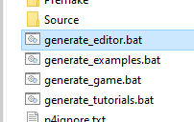
Run the generate_editor.bat script to generate visual studio solution file and the projects needed. Once done open the GameEditor.sln file in visual studio.
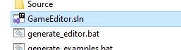

A quick rundown of the project structure
First of all, there are multiple projects in the GameEditor solution.
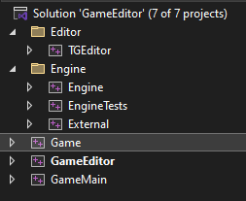

TGEditor
This is the implementation specifically for the editor, any tools and editor functionality goes in this project. It builds a static library so that the editor can be linked to any Game, this way the Editor isn’t tied to the Game project and could be used by multiple Games. This is not the first project to poke around in generally, but once comfortable with the structure, you can edit, add or remove functionality, tools and features in the editor!

Engine
This is the TGE core, also built as a static library linked by other projects to provide the TGE library functionality to projects. This is another project you might not work in for a while still, but again, if you find that you are missing a feature, or perhaps just some utility functionality that would help you in the game development nothing is stopping you from adding that functionality.

EngineTests
Unit-tests for TGE, there isn’t a lot as it is a new project. Feel free to add tests to TGE as you see a need for them.

External
Any code we use, but doesn’t produce ourselves goes here, such as parsing json, reading DDS files, gui framework and more. All the dependencies where we have the source code are built into a static library. You are somewhat likely to at some point add 3rd-party dependencies during your time at TGA. This is a good place to add them to have them built into the external library.

Game
This is your game! The engine setup is done in the Go.cpp file and the main loop run here. An instance of GameWorld is instantiated and updated in the loop. The GameWorld class has a place to initialize, update and render the game. Here you will spend most of the time, and already in the next part we are going to work to cleanup here, and later we read the data produced by the editor here as well. This is another project built to a static lib, this makes it possible to let the editor interact with the game without the need for coupling.

GameEditor
This does not build a static library, it builds an executable, namely the Editor executable used to run the editor! It does link many of the libraries produced in the other projects though. This project is quite simple, it consists of just one file, the main.cpp which more or less just a main function calling the go function in the project Game.

GameMain
Very similar to the GameEditor project. It builds an executable making use of libraries. It is also just a launcher which doesn’t do much more than starting up the editor. The main architectural reason that both the implementation for the game and the editor are in static libraries are so that we can link functionality. If the game was built as one executable instead of splitting it into one executable and one static library, we couldn’t link the game to the editor and so on.

Clean up default game example code
Now that we know a bit about the overarching structure. It’s time to do some cleanup. First removing the default example code, and down the line, start to implement functionality to interpret levels.
This is done in GameWorld.h and GameWorld.cpp which belong to the Game project.

In GameWorld.h we wont need the example sprite
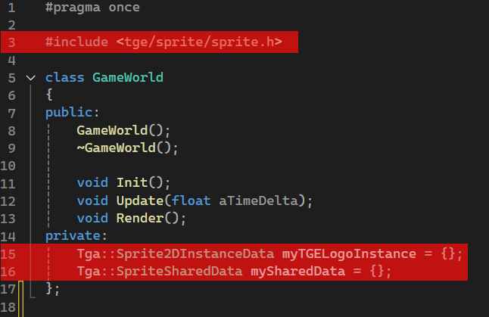

In GameWorld.cpp we can remove any use of the examples
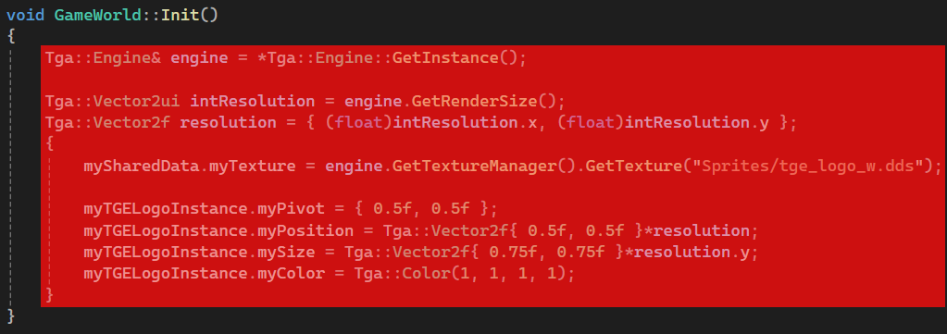
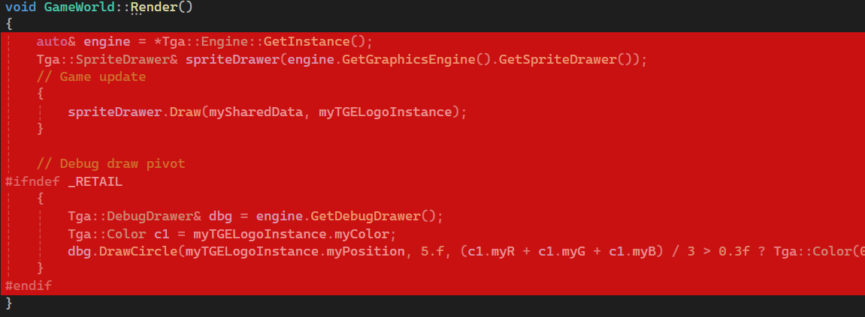
Leaving us with empty implementations

GameWorld.h
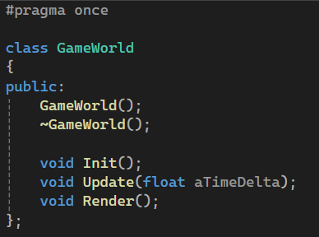

GameWorld.cpp
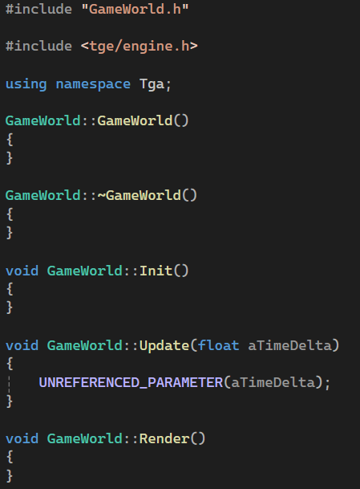
Everything should still compile and if you run the game it will show an empty window (previously it rendered a TGE logo).

Reading level data in game, produced in editor
If we first of all fire up the editor (set GameEditor as startup project in visual studio if it isn’t already set) and start the editor.
There should already be an empty scene in the asset browser
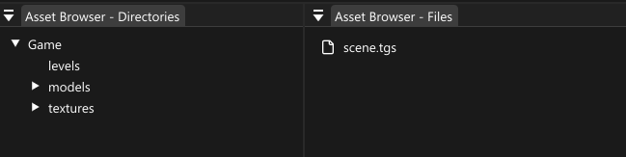
If there isn’t, you can create one. You do this by selecting New scene… from the File menu
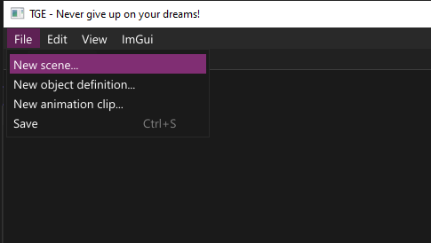
Double clicking the scene in the asset browser will load the scene and show it in the viewport.
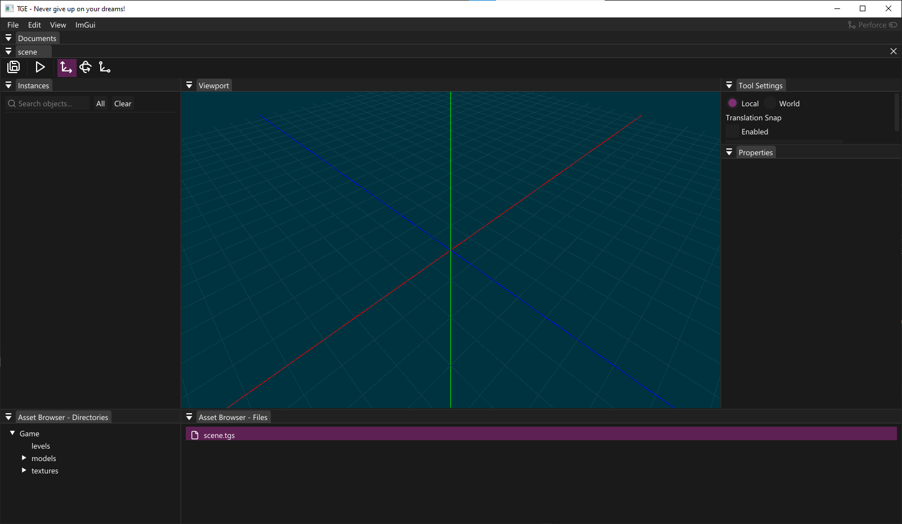
The scene is empty, so we will want to add something to it. We will create a new file. In the File menu, select New object definition…
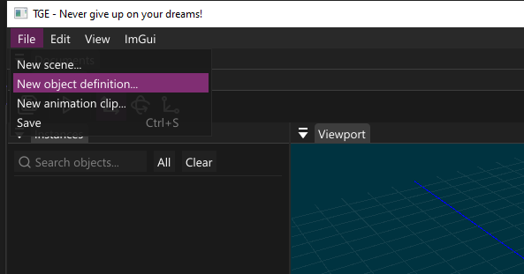
Select a name for the object, for example tge-logo and create the file. This will produce a .tgo object definition file.
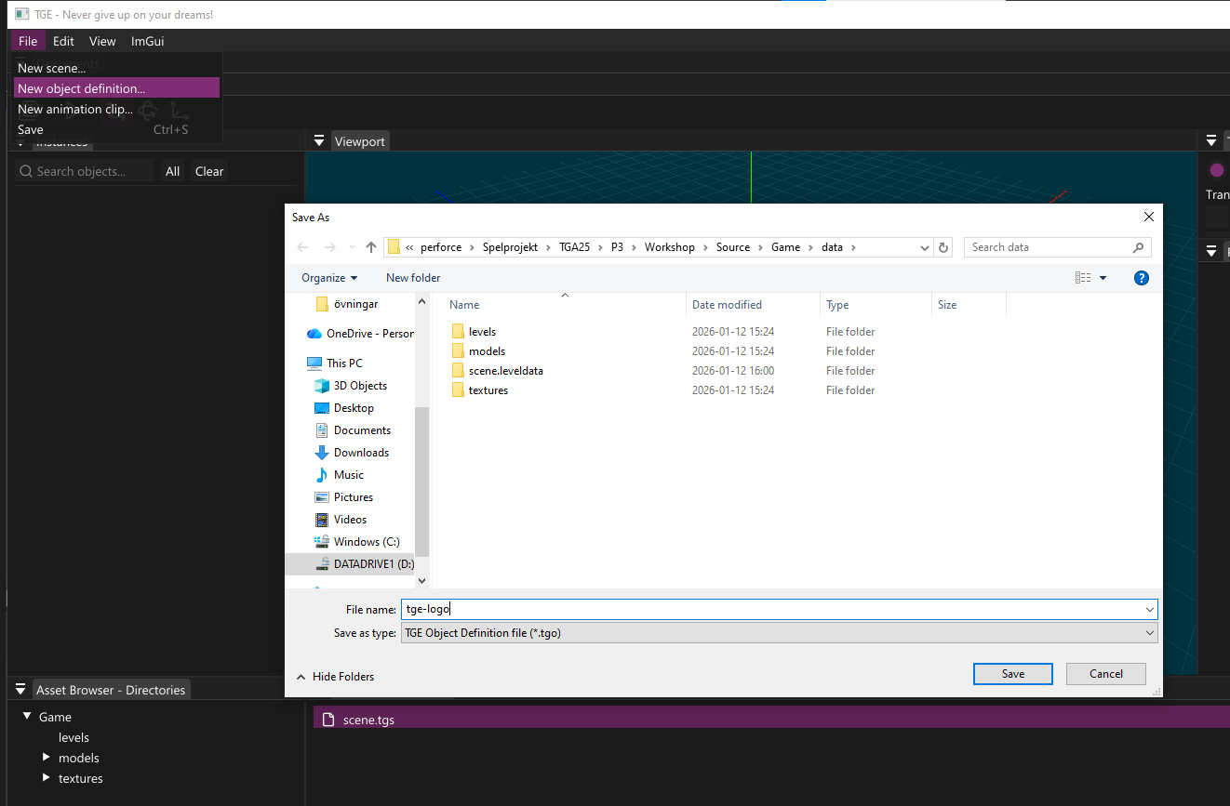
You should see the file in the asset browser (dependent of where you created the file, I put it just in the root data folder of the game)
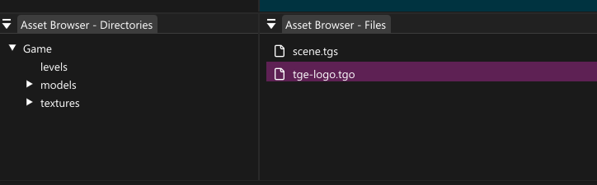
The Object definition editor should have automatically opened when you created the .tgo file. If it for some reason didn’t, or you want to open the editor for a .tgo you can double clicking the .tgo file in the asset browser.
- In the left (1) panel we can add, select or remove properties
- a viewport in the center (2) where any model property is shown
- To the right (3) we can view selected property data
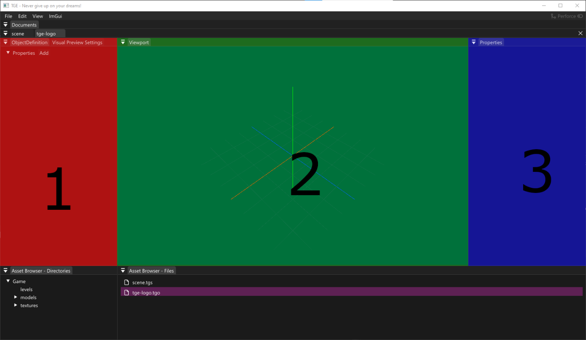
We will give the object a model to draw. We do this by adding a property, by selecting Add in the left panel (1) and select Model from the dropdown
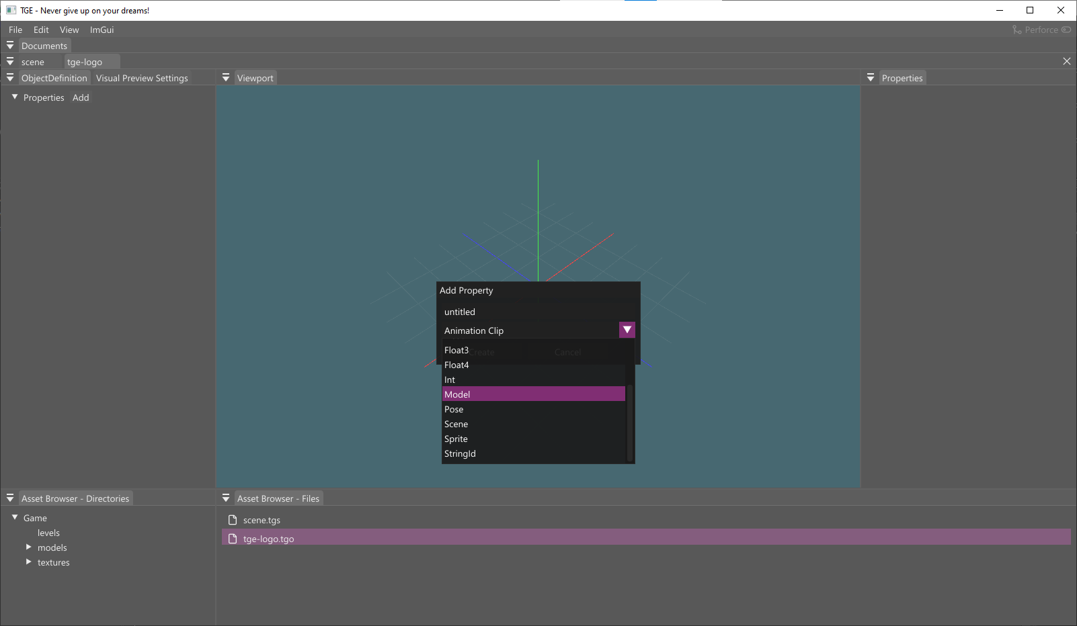
Give it a useful name, perhaps tga-logo and click Create. Make sure that the new property added to the left (1) is selected and you will se property data in the right(3) panel
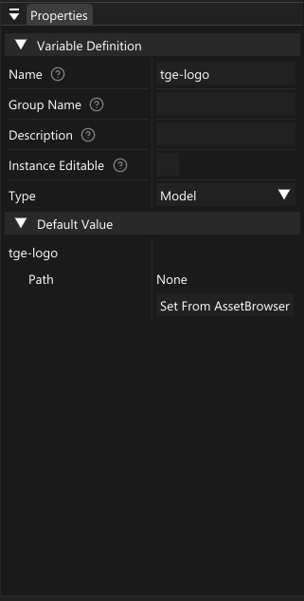
In the top part you find variable definition where you can do things like changing name, type and so on. And you can also set if this property is shared by all instances, or if you want to be able to set this property per instance.
Under you can see the default value part, and this is where we will specify the fbx file to use. So in the asset browser – directories, click on Models where you will find TGE.fbx. While it is selected (highlighted in purple)
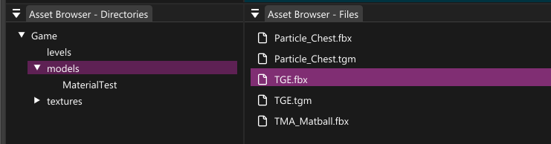
Click Set from asset browser to set the fbx
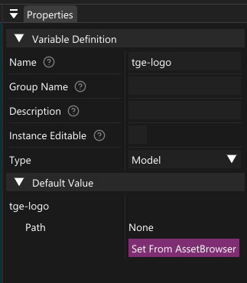
Which should result in a TGE logo being rendered in the viewport
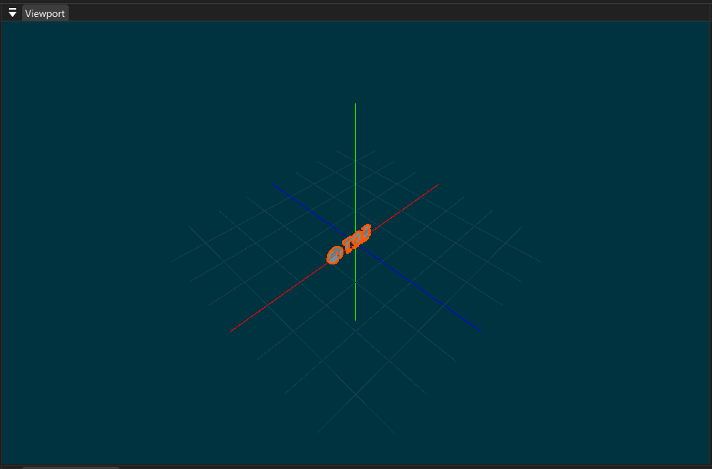
We will give it one more property, mainly to use in code later. Add another property in the left (1) panel, give it a name, for example rotation and select float as the type from the dropdown menu.
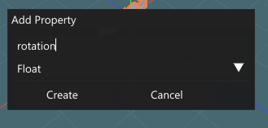
With this new property selected check the instance editable checkbox
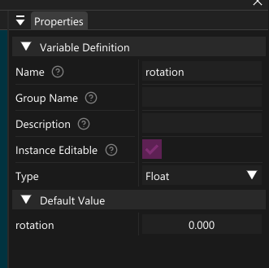
Save the .tgo (CTRL+S) and go back to the scene tab (or double click in asset browser, if it isn’t open)
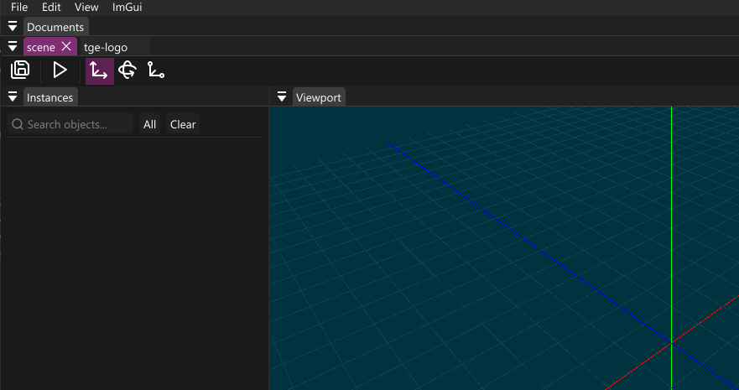
The scene viewport is empty, because we haven’t added any object to it. The way we add an object to a scene is by drag and dropping a .tgo file onto the viewport. So find the tge-logo.tgo file in the assetbrowser
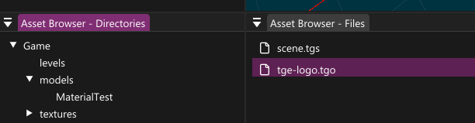
And drag it onto the viewport of the scene editor
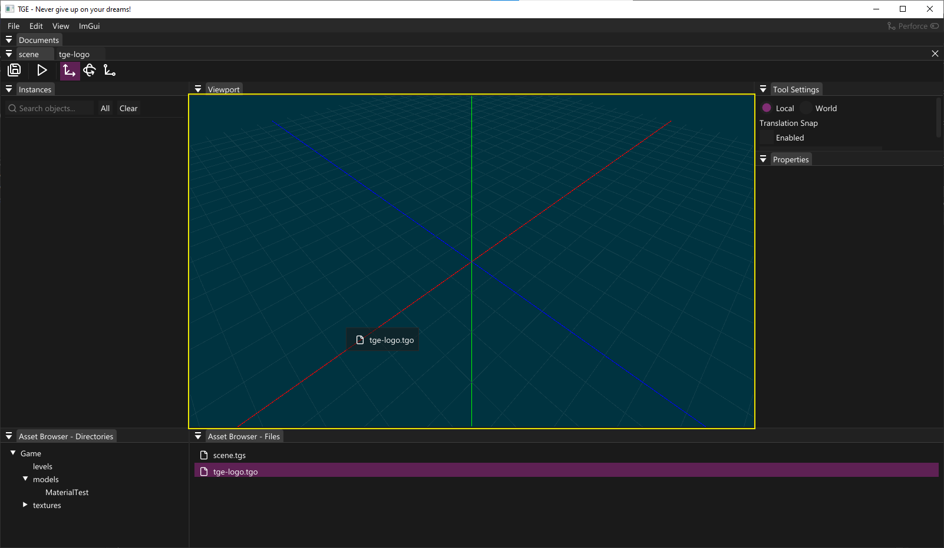
This will spawn an instance of this object, let’s move it -100 units in the x-direction
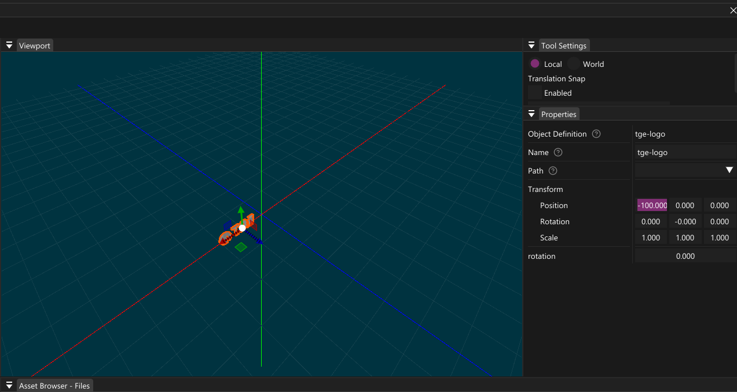
We will want another instance of this object in the scene. We can do this by selecting the object, so that it show with an orange outline and hit CTRL+D, this creates another instance duplicate. Move it to 100 units in the positive x-direction
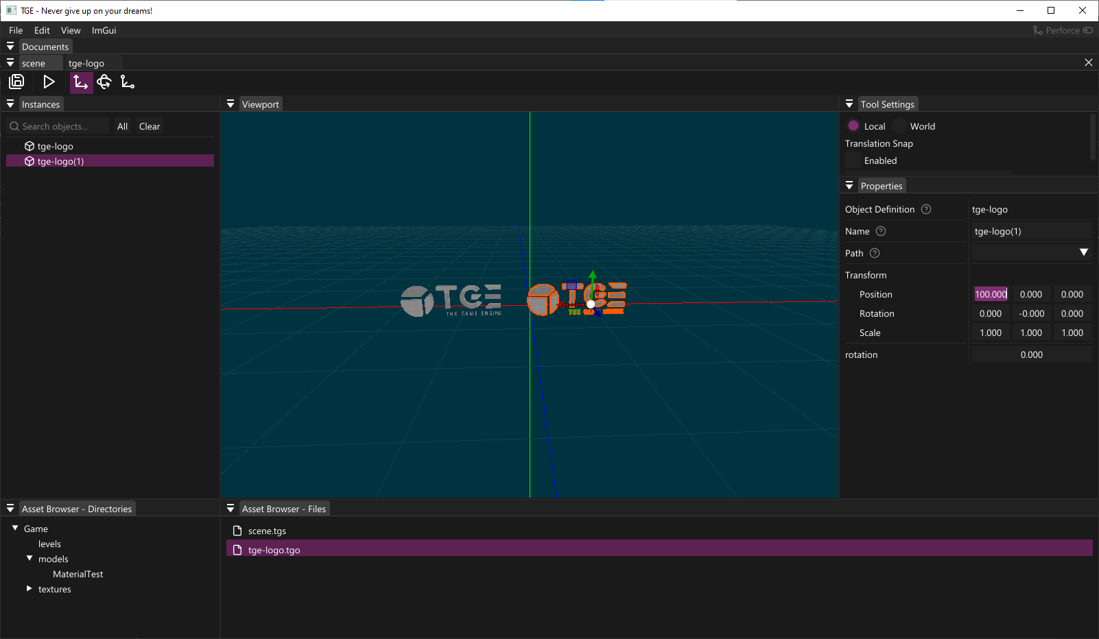
For this second object, change rotation to 100.0
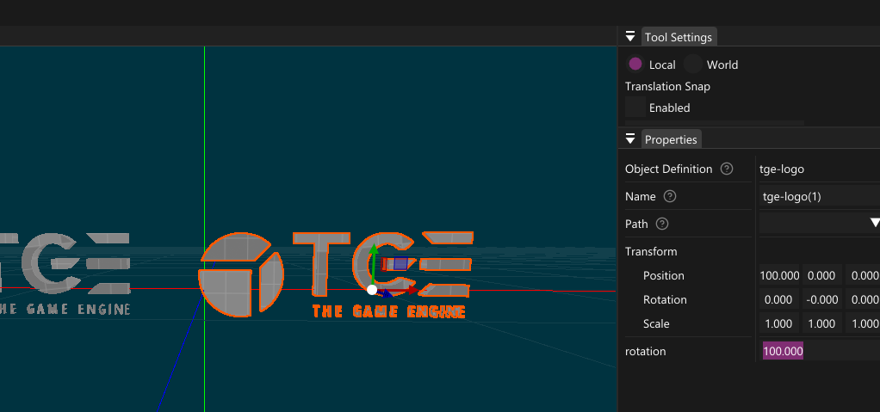
Save the scene (CTRL+S) and we can close the editor, next part will be to read the scene data in game so that the game reflects the changes we have just done using the editor.

Making use of editor created levels in Game
There are many ways do implementation, personally I usually outline the functionality I want to create in comments as an initial step. What I did when creating this introduction material was to first outline the general steps needed to get the scene we created into our game.

GameWorld.cpp annotation
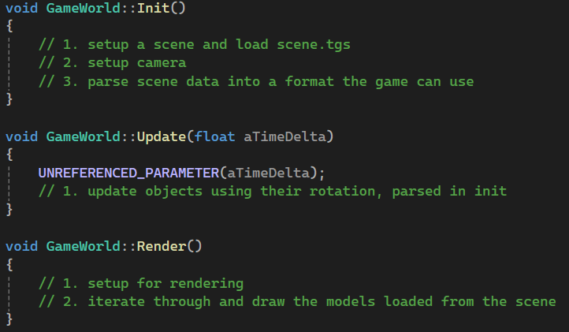

GameWorld.h
In the h-file I decided that I wanted to have a general camera for my GameWorld. So I added a TGA::Camera as a private member of GameWorld. I also opted to have it as a std::unique_ptr. The reasoning is that I might not want to include the Camera.h but I still want to have a Camera owned by GameWorld. So having a unique_ptr made sense. So my updated GameWorld.h looks like this
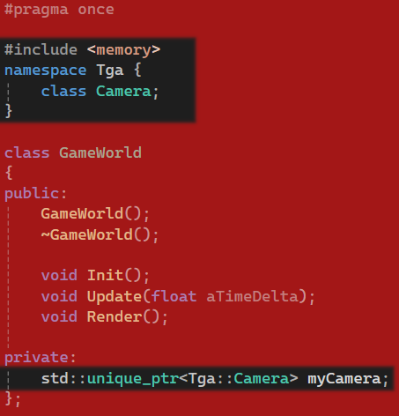

Initialization for Game
I identified three outlining points and actually kept pretty well to it, so I will show each part with a short discussion motivating and explaining the implementation.

Setup a scene and load scene.tgs
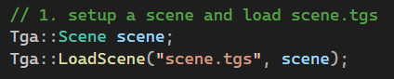
Here I set up a scene object and call the LoadScene function, what this does is that it populates the scene object with data from the editor created scene.tgs file. If you want to know more about how it is done have a look at the LoadScene function.

Setup camera
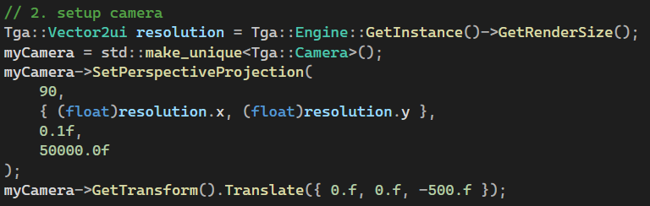
Here I set up a perspective camera and translate it 500 units back, which should be a good starting point as I know that the objects I created in the editor sit close to the origo a camera looking down the z-axis from 500 units back should see my objects.

Parse scene data into a format the game can use
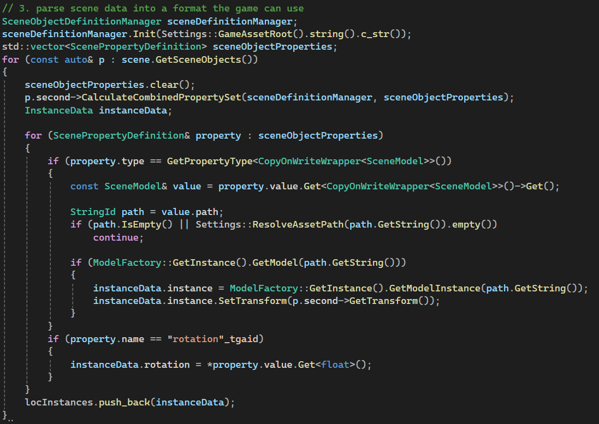
This is the biggest and probably most intimidating part of the initialization. I will try to go through it and give a rundown of the parts. But in general it goes through all objects in the level, and for each object it iterates over the properties (in our objects we have two properties, the mesh that we named tge-logo and the float that we named rotation). The data doesn’t carry any logic or functionality. You are responsible for deciding what you do with the data.
I created a struct to hold the data per object, and a std::vector so that I can create one instance of the struct per object read from the level:
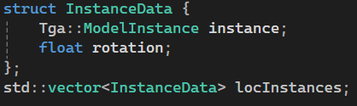
When iterating through the objects, for each object I iterate the properties. I query the properties to identify which property we are currently looking at.

Property with type: Model
If the property I am currently looking at has the type model I know that it has the property data corresponding to a model property in the editor, as seen here:
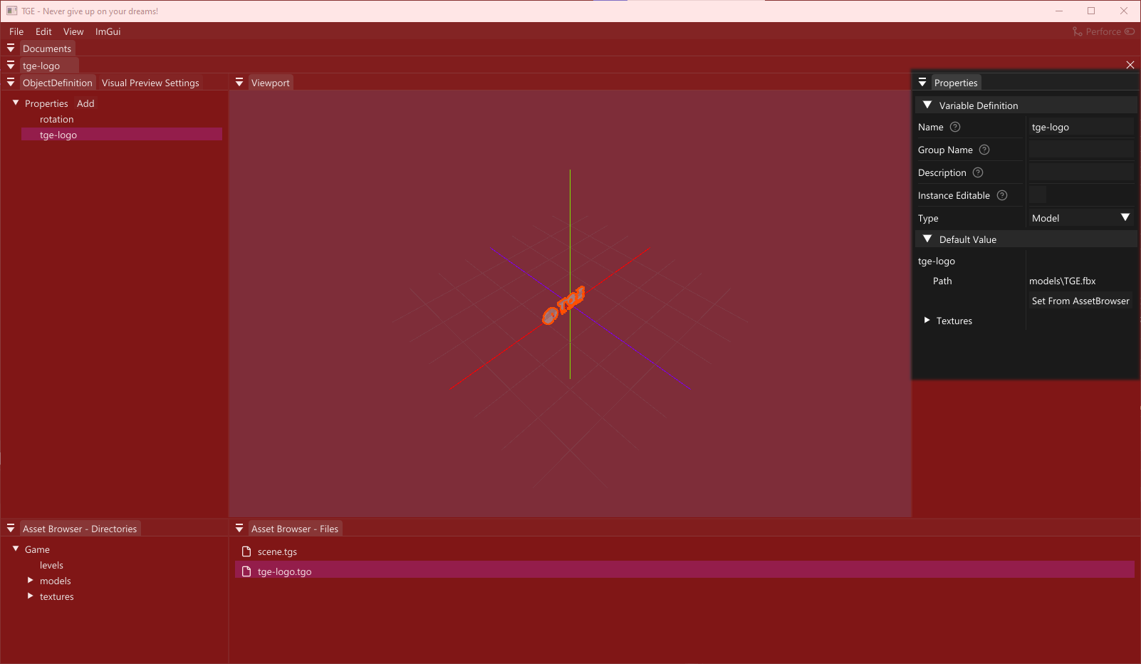
In this implementation I only load and setup the ModelInstance but if we had setup textures for example we could have read that information here as well (for a bigger example where textures are used run generate_examples.bat and have a look at the Examples solution were that is done).
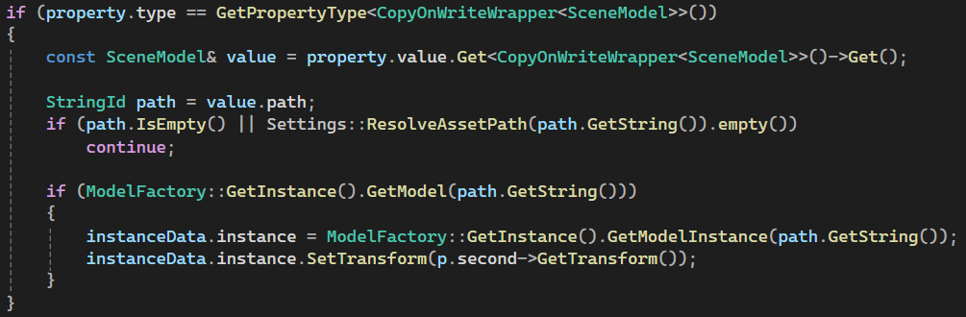
I am doing one more thing here, and that is reading the transform of the scen-object (the representation of the object read from the editor-created level) and apply that to the ModelInstance. I could have kept it separate as I do for the rotation (outlined below), or come up with another solution if I wanted, for this example I felt it simplest to let the ModelInstance handle it’s transform since it is used in a way where it made sense to directly making use of it.

The float (rotation) property
If the property name was rotation then I chose to store that together with the model and to organize it I created the InstanceData struct. So here I don’t do much at all, just reading the value and storing it in the instance.
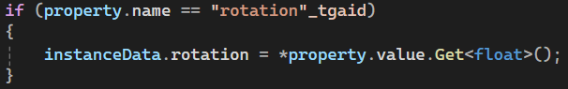
When all instances in the level, and their properties, has been iterated over the locInstances vector has been populated with the data which were created in the editor and I am free to use it to create the game!

Updating the game
I kept close to my initial comment in the update function as well. I iterate over the instances that I constructed in the initialization step after reading the editor constructed level file. For each instance I apply the rotation around the z-axis and that is all I have done.
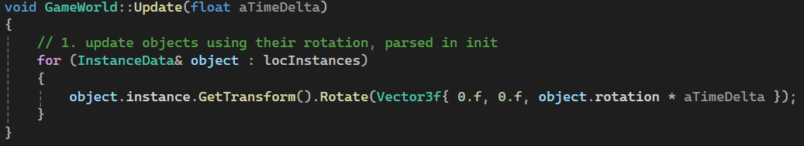

Rendering the game
Again I were able to keep to the initial outline in comments where I started out.
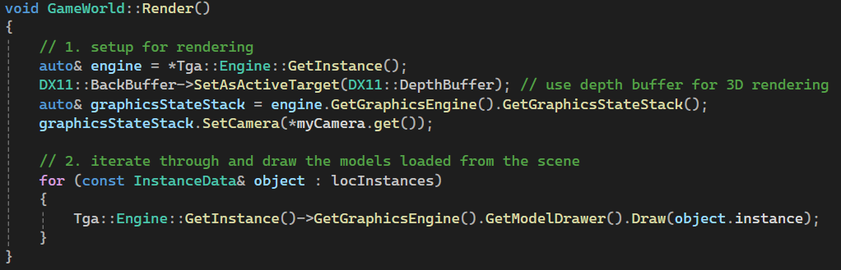

Render initialization
So there is one part where I do some setup, I enable depth buffer since the scene is rendered in 3D, if I didn’t we might get some overdraw or strange behavior (suggestion: try to comment it out and see what happens ^^).
I also set myCamera, which I did setup for in the init-function, to be used when rendering.

Rendering the instances
After setting up to render I then just loop through all the instances and draw them.

Conclusion
This is all the material I wanted to run through as a quick guide for getting started when doing your first game project in TGE.
From here it is suitable to have a look at the Examples which can be generated by running generate_examples.bat and especially looking through the Platformer example. It does much of what we have done in this guide, but more of everything with more complex behavior. It also show more examples of different types of properties and more decisions are made regarding how to use what we create in the editor.
The tutorials are also a good place to go a bit deeper. You generate them by running generate_tutorials.bat and that will provide a solution with multiple tutorial-projects with different examples of how you can do things using TGA. The tutorials don’t use the editor and typically not a GameWorld object but rather they aim to keep it very simple where a function runs a game loop where some concept is exemplified.
Other than that there isn’t much more to say, time to create games, edit and extend the engine with features and create new tools in the editor!

